# CS 255 System Design Document

## UML Diagrams

### UML Use Case Diagram

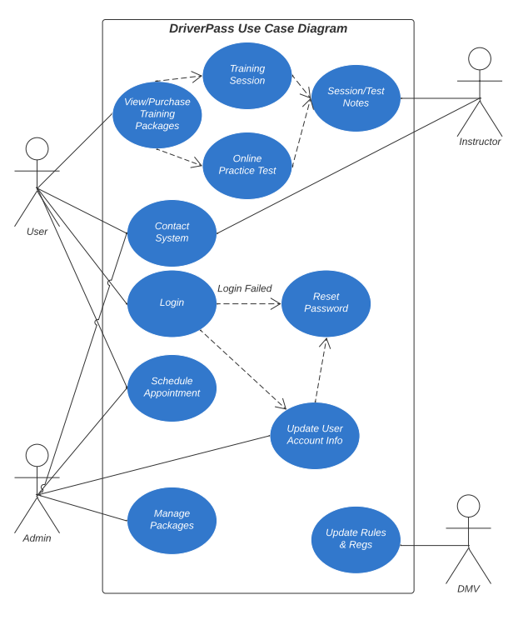

### UML Activity Diagrams

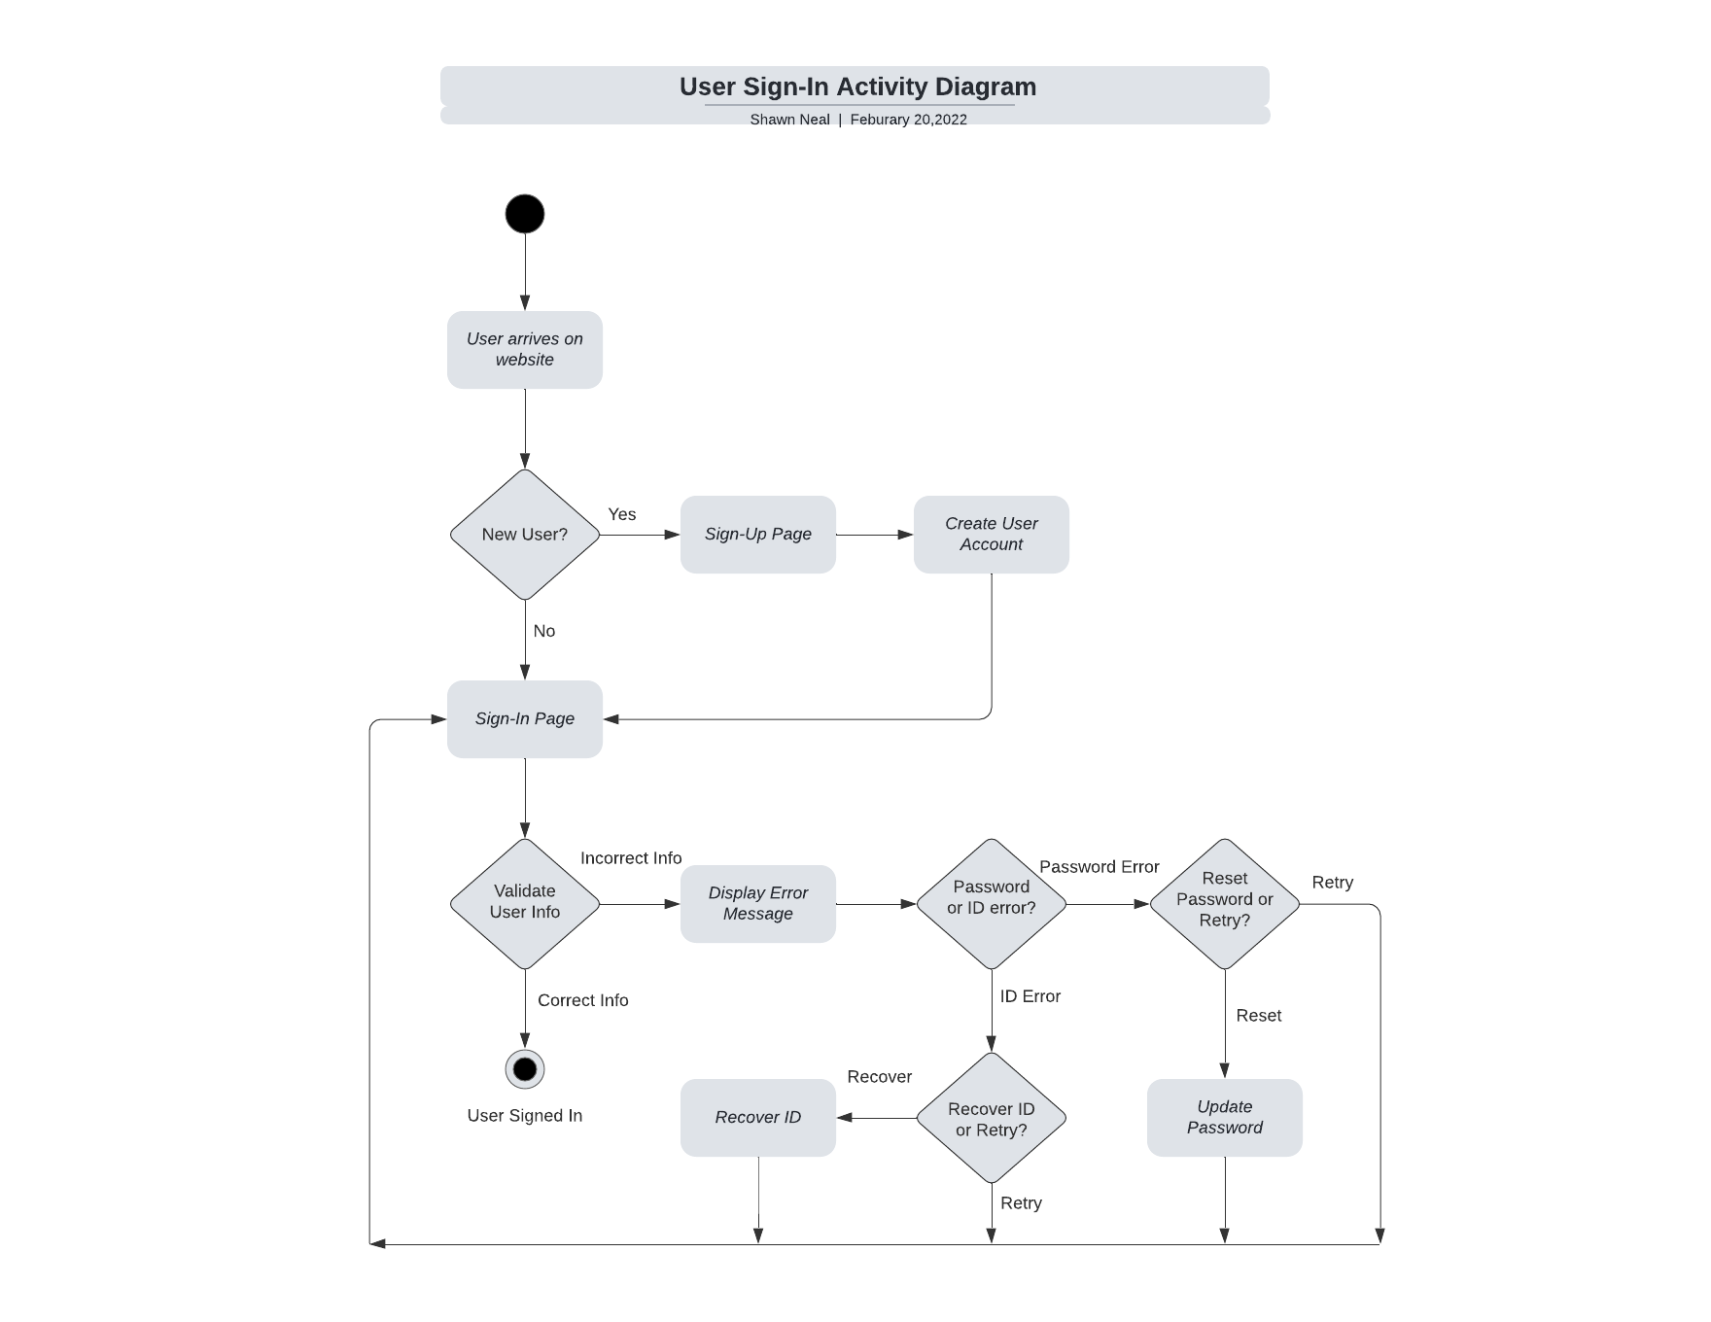

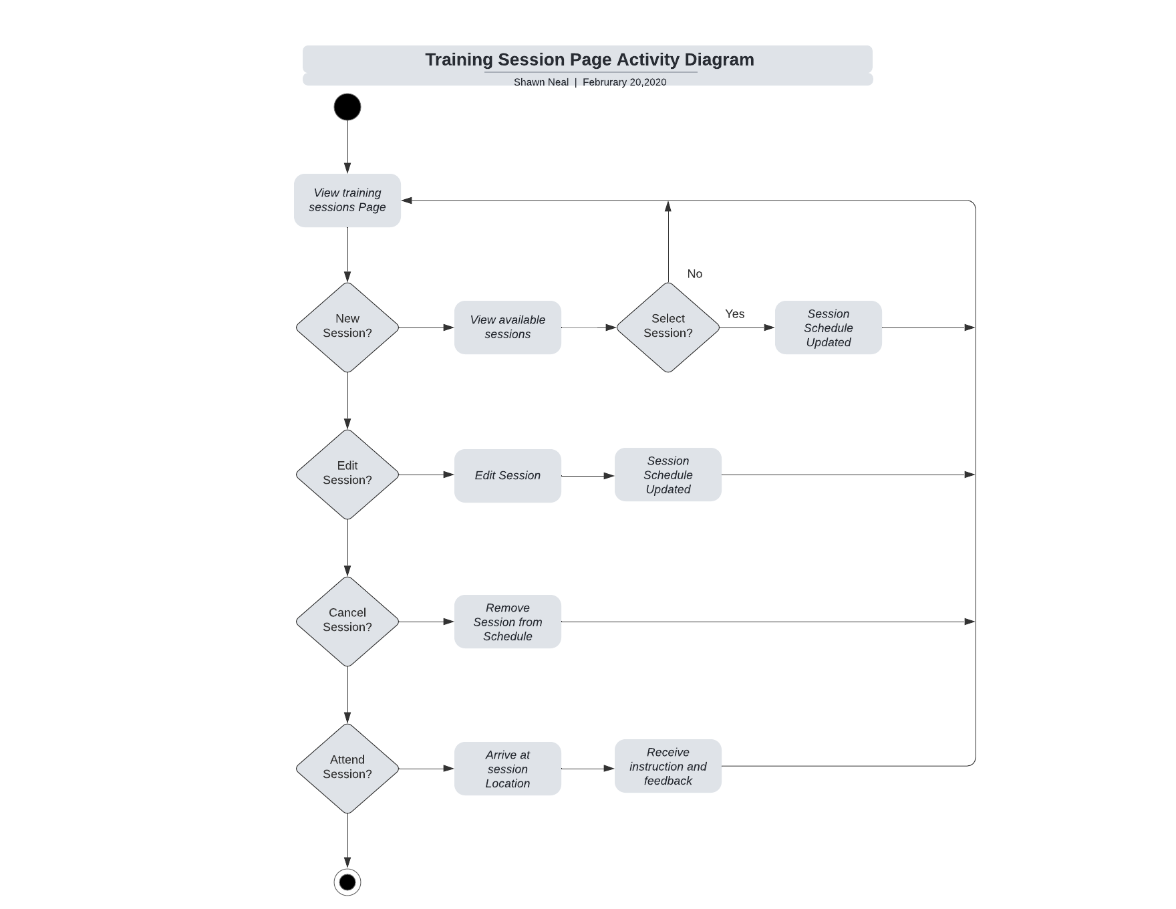

### UML Sequence Diagram

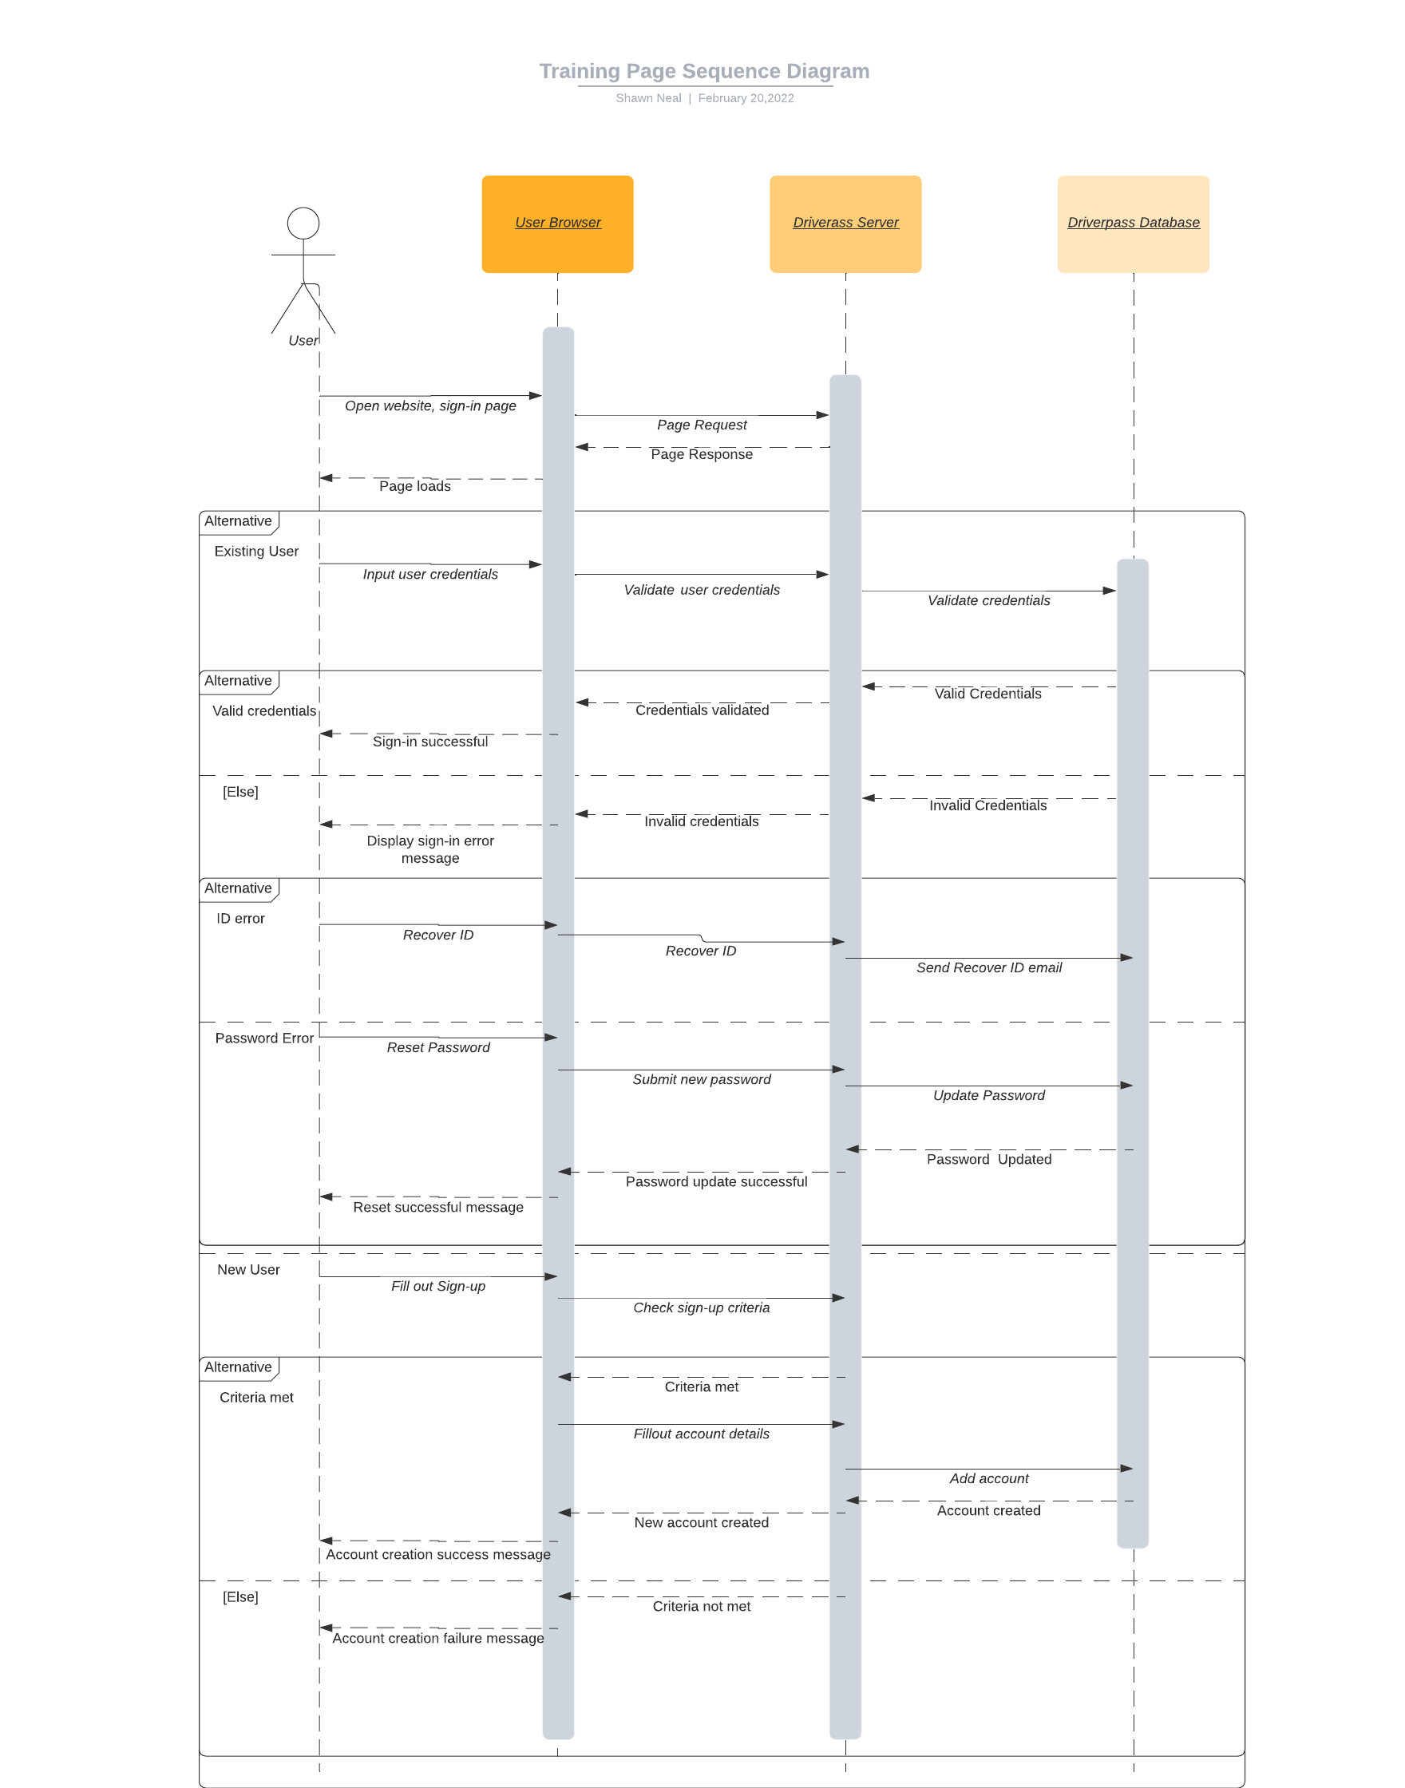

### UML Class Diagram

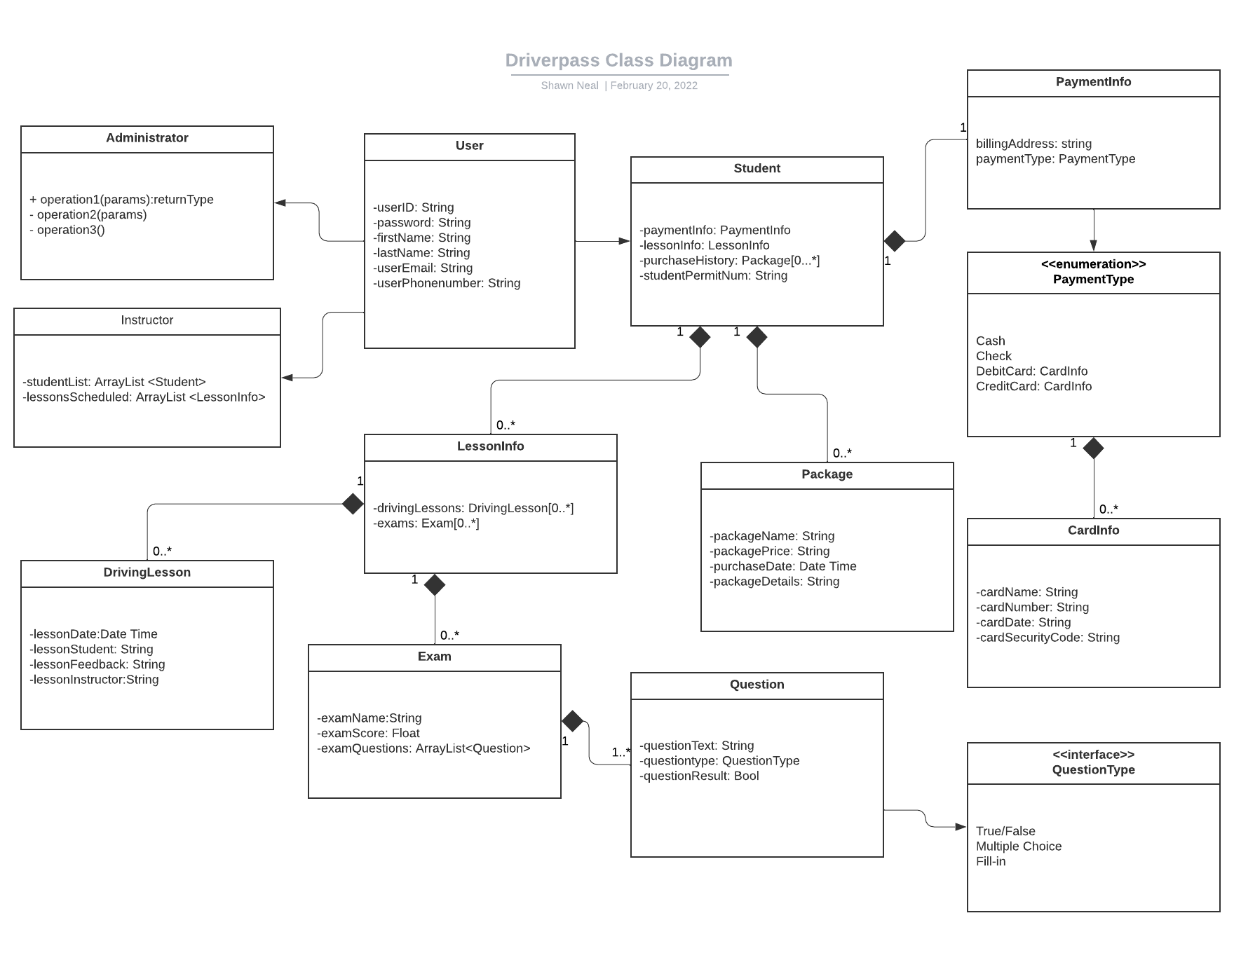

## Technical Requirements

* Hardware
  + Webhost
    - Cloud-based servers rented through third-party web-hosting service
  + Client devices using modern internet browser
    - Laptop/Desktop computers
    - Smart phone
    - Tablet
* Software
  + Access via web-browser
  + Operated via cloud-based servers.
  + Browser support, but not limited to:
    - Microsoft Edge
    - Chrome
    - Firefox
    - Safari
  + Security suite
  + Operating system agnostic
* Tools
  + Microsoft Office suite for documentation
  + Development hardware
    - Developer workstation
  + Development stack, including but not limited to, frontend, backend and database, automatic testing suites, version control
  + Modern IDE for Development
    - Eclipse
    - IntelliJ
    - Visual Studio
* Infrastructure
  + High-speed internet
    - Physical (ethernet)
    - WiFi
    - 4g/5g